**Title (Present a title that includes, if appropriate, the research design)**

First author1, Co-author2, list full names of co-authors…………, Corresponding author1, *

1 The address for the authors of #1 research group

2 The address for the authors of #2 research group.

* indicates the corresponding author

* Corresponding author: Full name of #1 corresponding author, Full name of #2 corresponding author if applicable

Tel.: +82-31-750-9766

E-mail address: email addresses of corresponding authors

**Abstract**

The abstract should briefly summarize the aim, findings or purpose of the article. Please minimize the use of abbreviations and do not cite references in the abstract.

Key words: Three to ten keywords representing the main content of the article.

**1. Introduction**

The Introduction section should explain the background to the study, its aims, a summary of the existing literature and why this study was necessary.

* If abbreviations are used in the text they should be defined in the text at first use, and a list of abbreviations should be provided.

**2. Methods/Experimental**

This section can be composed of sub-sections if appropriate.

**2.1 Title of sub-section**

The section should include: (1) the aim, design and setting of the study; (2) the characteristics of participants or description of materials; (3) a clear description of all processes and methodologies employed. Generic names should generally be used. When proprietary brands are used in research, include the brand names in parentheses; (4) the type of statistical analysis used, including a power calculation if appropriate; (5) studies involving human participants, data or tissue or animals must include statement on ethics approval and consent.

**2.2 Title of sub-section**

**2.3 Title of sub-section**

**3. Results and Discussion**

This section can be composed of sub-sections if appropriate. This should include the findings of the study including, if appropriate, results of statistical analysis which must be included either in the text or as tables and figures.

**3.1. Title of sub-section**

**FIGURES**; Each figure must have a caption that includes the figure number and a brief description, preferably one or two sentences. All figures must be mentioned in the text consecutively and numbered with Arabic numerals. The caption should be understandable without reference to the text.

**3.2. Title of sub-section**

**SCHEMES**; Groups of reactions that show action are called schemes. Schemes may have brief titles describing their contents. The title should follow the format "Scheme 1. Scheme Title".

**3.3. Title of sub-section**

**TABLES**; Each table must have a brief (one phrase or sentence) title that describes the contents. The title should follow the format "Table 1. Table Title". The title should be understandable without reference to the text. Put details in footnotes, not in the title. Tables should be simple and concise.

**4. Conclusions**

This should state clearly the main conclusions and provide an explanation of the importance and relevance of the study to the field.

**Declaration**

All manuscripts must contain the following sections under the heading 'Declarations':

**Acknowledgements**

Please acknowledge anyone who contributed towards the article who does not meet the criteria for authorship including anyone who providing professional writing services and materials. Authors should obtain permission to acknowledge from all those mentioned in the Acknowledgements section. See our [editorial policies](https://www.springeropen.com/get-published/editorial-policies#authorship)for a full explanation of acknowledgements and authorship criteria. If you do not have anyone to acknowledge, please write "Not applicable" in this section.

**Availability of data and material**(e.g.)The datasets used and/or analysed during the current study are available from the corresponding author on reasonable request.

All manuscripts must include an ‘Availability of data and materials’ statement. Data availability statements should include information on where data supporting the results reported in the article can be found including, where applicable, hyperlinks to publicly archived datasets analyzed or generated during the study. By data we mean the minimal dataset that would be necessary to interpret, replicate and build upon the findings reported in the article. We recognize it is not always possible to share research data publicly, for instance when individual privacy could be compromised, and in such instances data availability should still be stated in the manuscript along with any conditions for access. Data availability statements can be found in the manuscript preparation section.

**Competing interests**

See our [editorial policies](https://www.springeropen.com/get-published/editorial-policies#competing+interests)for a full explanation of competing interests. If you are unsure whether you or any of your co-authors have a competing interest, please contact the editorial office. Please use the authors’ initials to refer to each authors' competing interests in this section. If you do not have any competing interests, please state "The authors declare that they have no competing interests" in this section.

**Authors’ Information**

This section is optional. You may choose to use this section to include any relevant information about the author(s) that may aid the reader's interpretation of the article, and understand the standpoint of the author(s). This may include details about the authors' qualifications, current positions they hold at institutions or societies, or any other relevant background information. Please refer to authors using their initials. Note this section should not be used to describe any competing interests.

**Funding**

All sources of funding for the research reported should be declared. The role of the funding body in the design of the study and collection, analysis, and interpretation of data and in writing the manuscript should be declared.

**Authors’ contributions**

The individual contributions of authors to the manuscript should be specified in this section. Guidance and criteria for authorship can be found in our [editorial policies](https://www.springeropen.com/get-published/editorial-policies#authorship). Please use initials to refer to each author's contribution in this section, for example: "FC analyzed and interpreted the patient data regarding the hematological disease and the transplant. RH performed the histological examination of the kidney, and was a major contributor in writing the manuscript. All authors read and approved the final manuscript."

**References**

Examples of the American Physical Society (APS) reference style are shown below. See our editorial policies for author guidance on good citation practice.

1. *Article within a journal:* S Preuss, A Demchuk Jr., M Stuke, Appl. Phys. A 61, 33 (1995).

2. *Article by DOI (with page numbers):* MK Slifka, JL Whitton, Clinical implications of dysregulated cytokine production. J. Mol. Med. 78, 74-80 (2000). doi:10.1007/s001090000086.

3. *Patent:* LO Norman, U.S. Patent 4,379,752, 9 Sept 1998.

4. *Dissertation, PhD thesis:* JW Trent, Dissertation, University of California, 1975.

5. *Article by DOI (before issue publication and with page numbers):* MK Slifka, JL Whitton, Clinical implications of dysregulated cytokine production. J. Mol. Med. (2000). doi:10.1007/s001090000086.

6. *Article in electronic journal by DOI (no paginated version):* MK Slifka, JL Whitton, Clinical implications of dysregulated cytokine production. Dig. J. Mol. Med. (2000). doi:10.1007/s801090000086.

7. *Journal issue with issue editor:* J Smith (ed.), Rodent genes. Mod. Genomics J. 14(6) (1998).

8. *Journal issue with no issue editor:* Rodent genes, Mod. Genomics J. 14(6) (1998).

9. *Book chapter, or an article within a book:* DM Abrams, in Conductive Polymers, ed. by RS Seymour, A Smith (Springer, Berlin Heidelberg New York, 1973), p. 307.

10. *Complete book, authored:* H Ibach, H Lüth, Solid-State Physics, 2nd edn. (Springer, New York, 1996), pp. 45-56.

11. *Complete book, edited:* RS Seymour (ed.), Conductive Polymers (Plenum, New York, 1981).

12. *Chapter in a book in a series without volume titles:* DM MacKay, in Handbook of Sensory Physiology, vol. 3, ed. by R Jung, DM MacKay (Springer, Heidelberg, 1973), p. 307.

13. *Chapter in a book in a series with volume titles:* SE Smith, in Neuromuscular Junction, ed. by E Zaimis. Handbook of Experimental Pharmacology, vol 42 (Springer, Heidelberg, 1976), p. 593.

14. *Online First chapter in a series (without a volume designation but with a DOI):* Y Saito, H Hyuga, Rate equation approaches to amplification of enantiomeric excess and chiral symmetry breaking. Top. Curr. Chem. (2007). doi:10.1007/128_2006_108.

15. *Proceedings as a book (in a series and subseries):* D Zowghi, in PRICAI '96: Topics in Artificial Intelligence, ed. by N Foo, R Goebel. 4th Pacific Rim Conference on Artificial Intelligence, Cairns, August 1996. Lecture Notes in Computer Science. Lecture notes in artificial intelligence, vol. 1114 (Springer, Heidelberg, 1996), p. 157.

16. *Article within conference proceedings with an editor (without a publisher):* M Aaron, in Proceedings of the Genomic Researchers, Boston, 1999, ed. by H. Williams.

17. *Article within conference proceedings without an editor (without a publisher):* S-T Chung, RL Morris, in Abstracts of the 3rd International Symposium on the Genetics of Industrial Microorganisms, University of Wisconsin, Madison, 4-9 June 1978.

18. *Article presented at a conference:* S-T Chung, RL Morris, Isolation and characterization of plasmid deoxyribonucleic acid from Streptomyces fradiae. Paper presented at the 3rd international symposium on the genetics of industrial microorganisms, University of Wisconsin, Madison, 4-9 June 1978.

19. *Book with institutional author:* International Anatomical Nomenclature Committee, Nomina anatomica. (Excerpta Medica, Amsterdam, 1966).

20. *In press article:* R Holmes, in Science style manual, ed. by TC Jones (Sprint, London, 2006 in press).

21. *Online document:* J Cartwright, Big stars have weather too. (IOP Publishing PhysicsWeb, 2007), http://physicsweb.org/articles/news/11/6/16/1. Accessed 26 June 2007.

22. *Online database:* Healthwise Knowledgebase (US Pharmacopeia, Rockville, 1998), http://www.healthwise.org. Accessed 21 Sept 1998.

23. *Supplementary material/private homepage:* J Doe, Title of supplementary material (2000), http://www.privatehomepage.com. Accessed 22 Feb 2000.

24. *University site:* J Doe, Title of preprint (1999), http://www.uni-heidelberg.de/mydata.html. Accessed 25 Dec 1999.

25. *FTP site:* J Doe, Trivial HTTP, RFC2169 (1999), ftp://ftp.isi.edu/in-notes/rfc2169.txt. Accessed 12 Nov 1999.

26. *Organization site:* ISSN International Centre: The ISSN register (2006), http://www.issn.org. Accessed 20 Feb 2007.

**Figure captions:**

**Fig. 1.** Concise and understandable figure caption.

**Fig. 2.** Concise and understandable figure caption.

**Fig. 3.** Concise and understandable figure caption.

**Tables:**

**Table 1.** Table title

**Table 2.** Table title

**Fig. 1.**

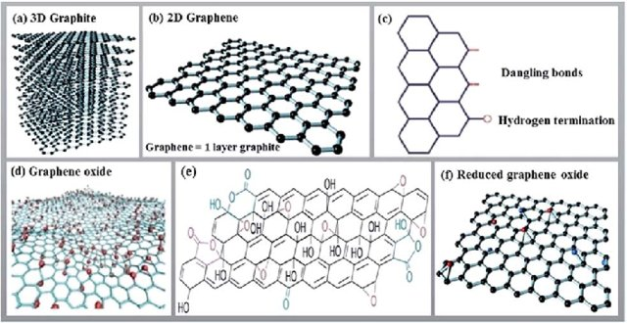

**Fig. 2.**

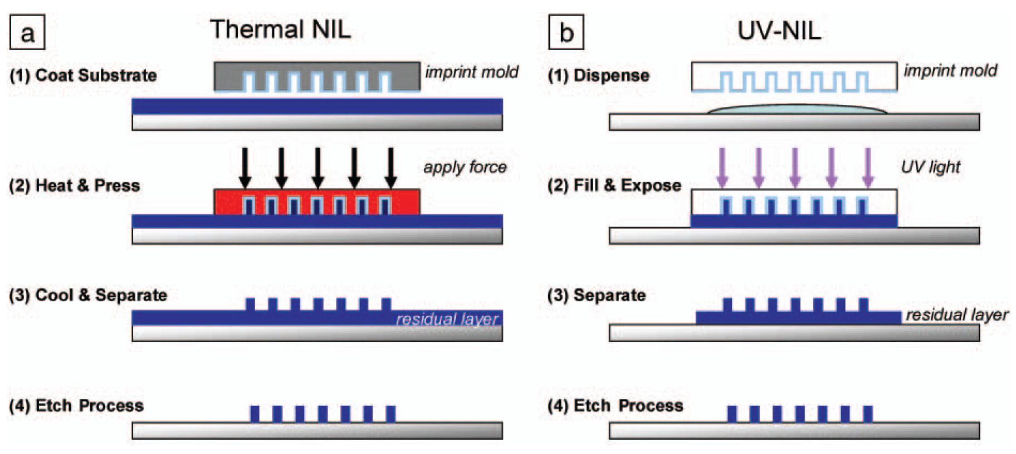

**Table 1.** Table title

|  |  |  |
| --- | --- | --- |
| Sample | Ra (μm) | Rb (μm) |
| A | 1 ± 0.15 | 10 ± 1.54 |
| B | 2 ± 0.17 | 20 ± 1.13 |
| C | 3 ± 0.13 | 30 ± 1.01 |
| D | 4 ± 0.10 | 40 ± 0.47 |